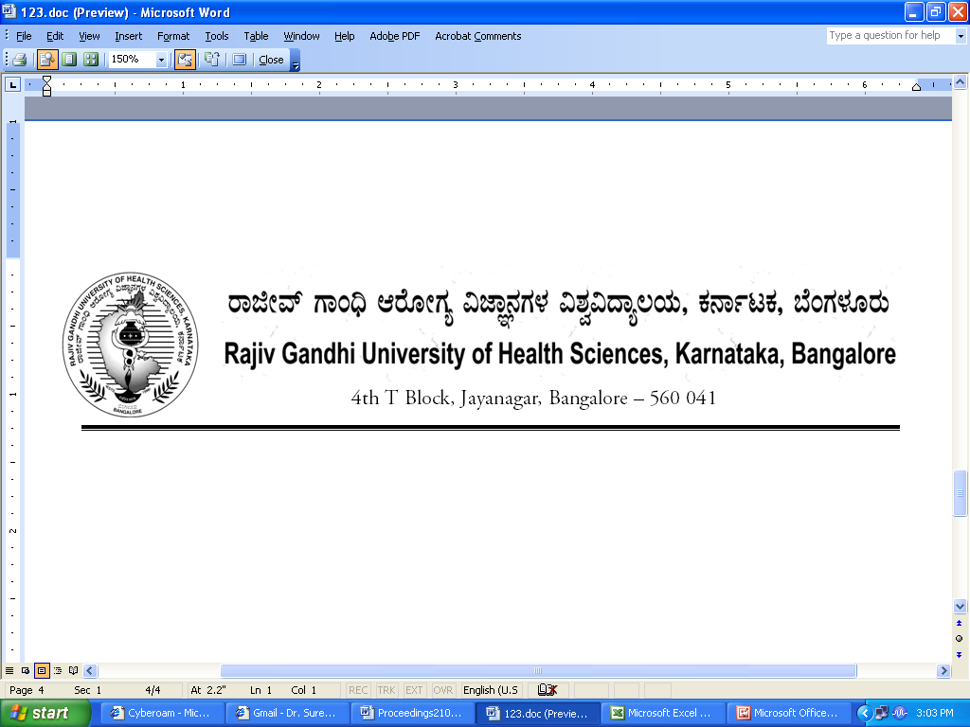
Reg(E)Exam/BPT/August /September- 2018 Date: 27/06/2018

ADVANCE NOTIFICATION

Sub: | Conduct of Under Graduate Physiotherapy Theory Examination during August/September- 2018.
********

The Theory Examination for below mentioned course, will tentatively commence from 21st August - 2018. The detailed Time Table will be notified in due courses.

 | COURSES | DATE
I | Under Graduate Physiotherapy | 21st August- 2018

The Principals of concerned Colleges are requested to notify this on the Notice Board of their colleges for information of the students concerned.

Sd/-

Registrar (Evaluation)
To:
All the Principals of concerned colleges for information and needful action.

Copy to:

- PA to Vice-Chancellor/Registrar/Finance Officer, RGUHS, Bangalore.
- Deputy Registrar (Admn) section for information and needful action.
- All the officers of the RGUHS, Bangalore.
- Asst. Registrar, Regional Center, Belgaum / Gulbarga.
- Guard File.

